TOPIC:  Kindness Club Meeting  All Activities, tools, etc. shown here are suggestions. Please feel free to substitute and/or modify as needed. Visit your Resource Library for tools, videos, speaker ideas, etc.  If your meetings are online, be sure to notify parents in advance about any materials needed so club members have supplies ready.  TOPIC AND DEFINITION  - “Check in” Connection activity - how are you feeling? Take a minute to get connected before we begin our meeting. Thumbs up/down, a game, discuss, journal, or take a moment to contemplate – can be quick & powerful.  - KM365 Tool Focus and get present with breathing/movement from the KM365 online toolbox or use your own.  - Review & Intro Review last month’s topic and introduce CURRENT MONTH’S topic (video you like, KM365 PowToon, dialogue, etc.)  - Understanding/Personalization Fun activity, game, story, dialogue/share, drawing, journaling, etc.:  - Non-Profit Speaker, Video, or Discussion Bring a speaker in, show a video from the Resource Library, or lead a discussion on Self Navigation.  - “Kindness in Action” Project or experience -create a hands-on project/experience in support of the speaker or about the monthly topic.  - Reflection Discussion from KM365 Reflection Prompts (found in the resource library for your age group).  - Peace Pledge Read Peace Pledge together (the one created by Kids for Peace on the dashboard or one your group created).  - Wrap Up Photos, certificates of appreciation, handouts. Please remember to post, and turn in your monthly reporting  Contact Ambassador Support at AmbassadorSupport@kindnessmatters365.org for questions or comments. 😊 | 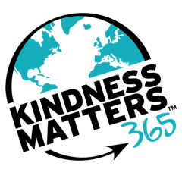  Your Notes

