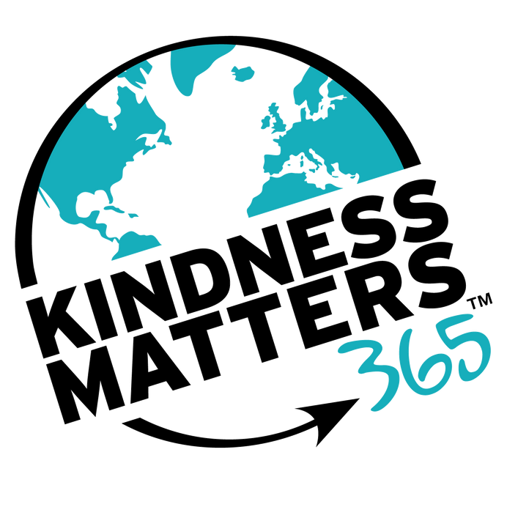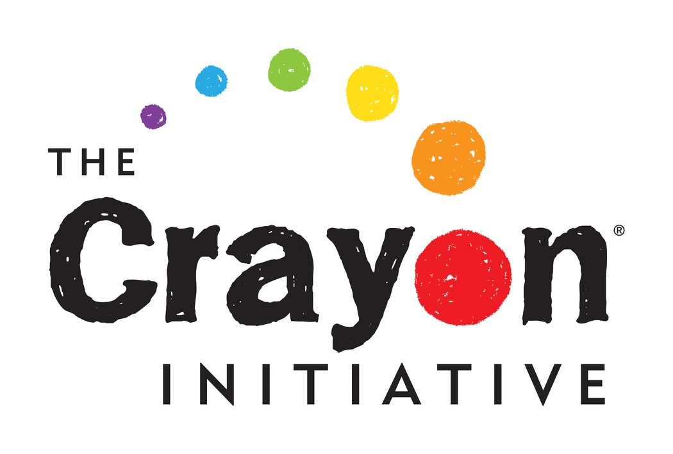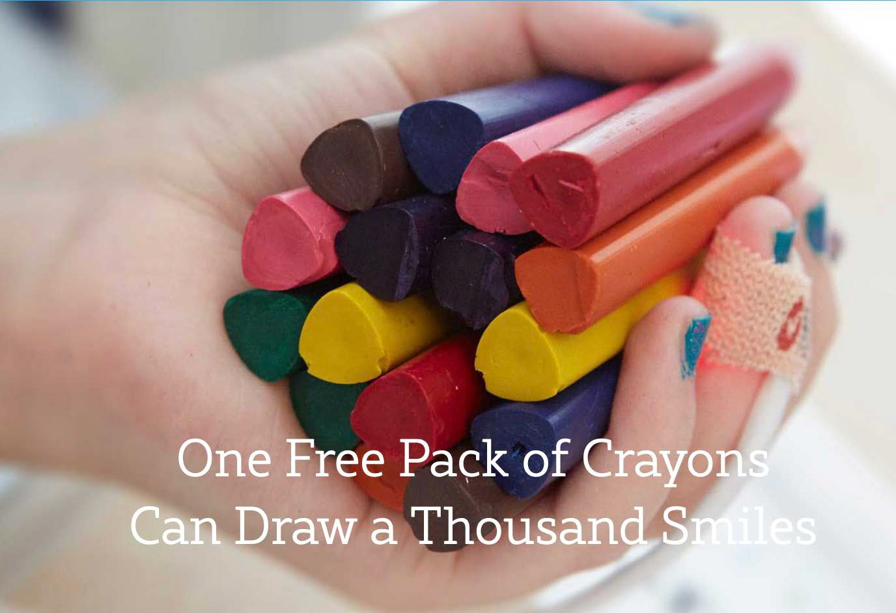KINDNESS IN ACTION

JOIN US IN BRINGING NEW LIFE TO USED CRAYONS AND SMILES TO PEDIATRIC PATIENTS

DROP OFF USED CRAYONS IN OUR DONATION BIN IN

BETWEEN NOW AND

The Crayon Initiative has given 624,600 boxes of new
crayons to children in over 240 hospitals, including
____________________________.

SCHOOL LOGO HERE

