KINDNESS IN ACTION

IT'S TIME FOR THE ANNUAL CEREAL DRIVE WITH KINDNESS MATTERS
365 AND CEREAL4ALL

DROP OFF UNOPENED BOXES OF CEREAL IN THE DONATION BIN IN

BETWEEN NOW AND

ADD DETAILS ABOUT CEREAL PARTY IF PROVIDING

SCHOOL

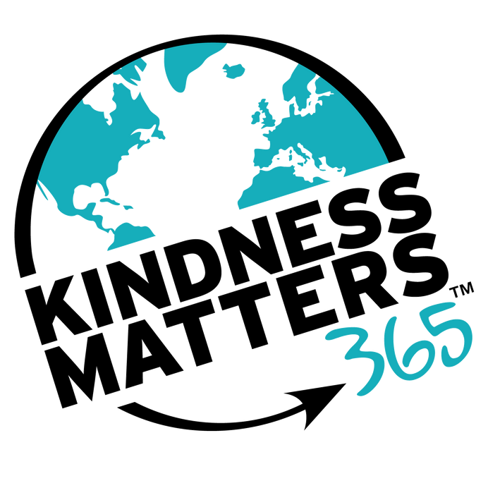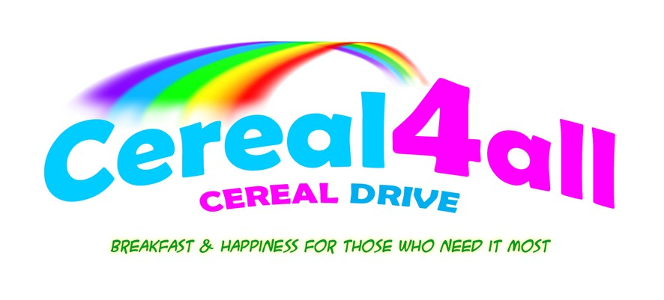Since 2016, Cereal4All has collected and donated over 96,590 boxes of cereal to kids and families in need.

LOGO HERE

